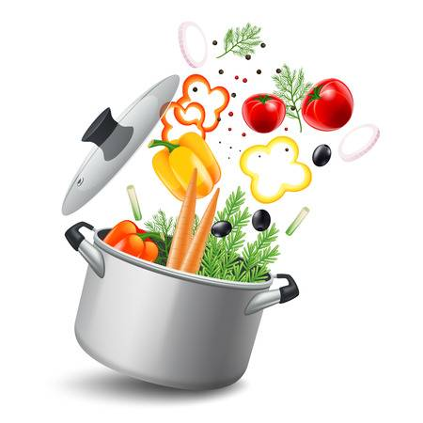
JUNIOR CERTIFICATE HOME ECONOMICS
FOOD & CULINARY SKILLS EXAMINATION 2018

Task No. 7 | Exam No.
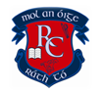
One pot/casserole meals offer a simple cooking method that easily combines ingredients in one pot while cooking. List some interesting one‐pot/casserole main course dishes. Prepare, cook and serve one of the main course dishes you have listed. Prepare and serve a suitable accompaniment to complete the main course of the meal. Calculate the cost of the main course dish

Analysis of task:

Factors to consider:
Accompaniament:

One pot dishes – advantage:

One pot dishes – disadvantage:

Possible Solutions
One pot main course
Casseroles

My Solution
Savoury Dish: | Accompaniament:

Reasons why I chose them:

Ingredients & Equipment Needed
Ingredients |  |  |  | Equipment
Amount |  |  | Cost  Total Cost:  € | Serving Equipment:
 | Time Plan
- Preparation (30 minutes):

- Exam (1 hour 30 minutes):

