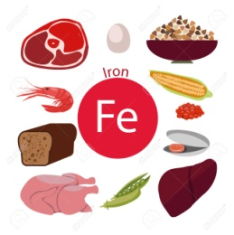
JUNIOR CERTIFICATE HOME ECONOMICS
FOOD & CULINARY SKILLS EXAMINATION 2018

Task No. 4 | Exam No.

Certain people have special dietary needs. Design and set out a two course menu suitable for an evening meal for either: (i) a low-fat diet or (ii) an anaemic young adult. Prepare, cook and serve the complete main course of the meal. Prepare and serve the starter or the dessert to complete the evening meal.

Analysis of task:

Factors to consider:
Starter/Dessert:

What is anaemia?

What foods should a young adult with anaemia include in their diet?

Possible Solutions
Menu 1 | Menu 2
~~~~~ | ~~~~~

My Chosen Menu

Reasons why I chose this menu:
 | Ingredients & Equipment Needed
 | Ingredients |  | Equipment
 | Amount |  | Serving Equipment:  Serving Equipment:
Time Plan
- Preparation (30 minutes):

- Exam (1 hour 30 minutes):

