2016
Current intakes of dietary fibre are generally inadequate in adults, with over 80% not meeting the European Food Safety Authority (EFSA) recommendation of 25-30 grams per day. (National Adult Nutrition Survey, 2011)
The chart below provides information on the contribution of different foods to dietary fibre intake in Ireland for adults aged 18-64 years and those over 65 years.
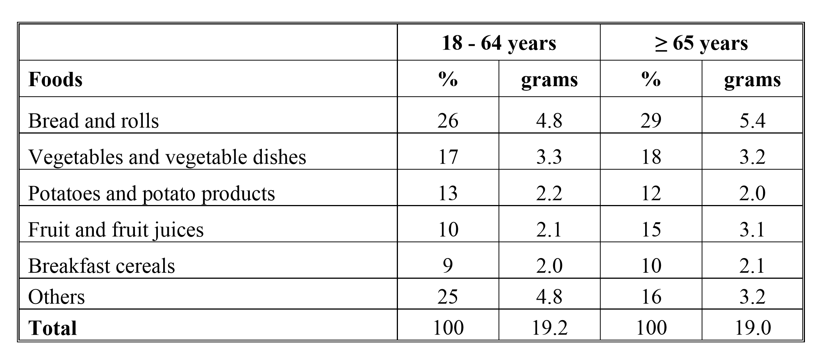
(a) Using the information provided in the chart, comment and elaborate on the contribution of four foods to the intake of dietary fibre with reference to the two categories of people identified above. (24)
(b) Suggest three strategies to increase the intake of dietary fibre in order to meet the European Food Safety Authority (EFSA) recommendation. (12)
(c) Evaluate the benefits of a diet rich in fibre. (15)
(d) Name and give an account of one bowel disease. Refer to symptoms / effects. (9)
(e) Evening work, night shifts and rotating work schedules can have a negative effect on normal meal patterns.
Suggest how individuals who have an irregular work schedule can manage to achieve a healthy balanced lifestyle and good dietary practices. (20)

2015
(a) Using the information given above, comment and elaborate on (i) the provision and (ii) the nutritional significance of the foods and beverages available to students in post primary schools. (24)
(b) Poor food choices have contributed to 42% of teenage girls and 23% of teenage boys not getting enough calcium in their diet. Give an account of calcium and include reference to:
• sources
• biological functions
• factors assisting/inhibiting absorption. (18)
(c) Explain (i) what is osteoporosis; (ii) the main factors that increase the risk of developing osteoporosis. (18)
(d) Discuss the role of parents in shaping their children’s food choices. (20)

2014
1. Shown below in the table is the cost (€) and percentage (%) of the weekly social welfare allowance required to purchase the foods necessary for healthy eating for four households using three different grocery store outlets.
(a) Evaluate shopping in the three grocery outlets referred to in the chart above. (12)
(b) Apart from family size, give three reasons for the variation in the percentage of income spent on food each week. (12)
(c) Protein rich foods are a significant cost for many families. Recommend a variety of low-cost protein foods and state how each can be incorporated into a healthy eating plan. (9)
(d) Give a detailed account of protein and refer to:
• classification (simple and conjugated) (24)
• supplementary value / complementary role (8)
• structure (primary, secondary and tertiary). (15)

2013
1. Irish healthy eating guidelines encourage people to eat a variety of foods based on the Food Pyramid. Findings are presented below on the percentage of respondents consuming the recommended number of daily servings from each shelf of the Food Pyramid (1998 and 2007).
(a) In relation to the information provided in the chart, comment and elaborate on the percentage of respondents consuming the recommended number of daily servings from each shelf of the Food Pyramid. (24)
(b) Identify and give an account of the main factors that are contributing to the prevalence of obesity in Ireland. (16)
(c) Outline the significance of fatty acids in the diet. (8)
(d) Describe the structure of each of the following:
• cis fatty acids
• trans fatty acids
• omega 3 fatty acids. (12)
(e) Discuss how food labelling assists consumers in making informed food choices. (20)

2012
‘Food-based dietary guidelines’ is the complete scientific term for a set of healthy eating messages provided for a population, in terms of how much and which types of foods to eat for good health. (Food Safety Authority of Ireland, FSAI)
New recommendations for food-based guidelines for healthy eating in Ireland were devised by the FSAI. An extract relating to the recommended servings per day for two food groups (bread/cereals and fruit & vegetables) is presented in the table below.
(a) In relation to the two food groups referred to in the table, comment and suggest reasons for the variations in the recommendations made. (24)
(b) Give an account of carbohydrates and refer to:
• the chemical structure of a monosaccharide
• the formation of disaccharides
• the hydrolysis of sugar to include inversion. (24)
(c) Discuss the importance of balancing energy intake and energy output. (12)
(d) Identify and discuss contemporary trends in food shopping practices. (20)

2011
The National Dairy Council (NDC) plays a vital role in driving a sustainable dairy industry in Ireland and in educating consumers on the role of dairy in their lifestyles.
The chart below provides information on the retail dairy market in Ireland in 2009 (excluding independent/doorstep sales).
(a) Using the information provided in the chart, comment and elaborate on consumer consumption of milk and dairy products in Ireland. (20)
(b) Give an account of protein and refer to:
• the structure of an amino acid
• how a peptide bond is formed
• properties. (28)
(c) Describe one process used by manufacturers to prolong the shelf life of milk. In your answer refer to:
• name of process
• how the process is carried out
• the effect of the process on the nutritive value of milk. (12)
(d) Comment and elaborate on the growing popularity of foods produced by small businesses and home enterprises. (20)

2010
1. Estimates of the distribution of Irish agri-food and drink exports in 2008 by sector are shown below.
(a) (i) Comment and elaborate on the distribution (%) of Irish food and drink exports as shown above. In your answer refer to four sectors.
(ii) Give details of career opportunities available within one of the sectors named. (24)
(b) Meat makes an important contribution to the intake of micronutrients such as iron.
Give an account of iron and refer to:
• sources in the diet
• biological functions
• recommended daily allowance (RDA) for adults. (21)
(c) Identify and explain three factors which affect the absorption of iron in the body. (15)
(d) Discuss the factors that may affect consumers’ decision making in relation to the purchase of meat and meat products. (20)

2009
‘The key to a nutritionally adequate vegetarian diet is balance, ensuring that where foods are specifically omitted, suitable alternatives are included so that dietary quality is not compromised.’ (British Nutrition Foundation, Nutrition Bulletin 30) The following table provides information on the nutritive value of minced beef and quorn mince. (Nutritional information per 100g).
(a) Using the information provided in the table, evaluate the contribution of quorn mince to the diet of vegetarians. (24)
(b) (i) Using quorn mince, plan and set out the menu for a balanced three course meal suitable for a vegan.
(ii) Indicate how the dishes selected meet the requirements of a vegan diet. (15)
(c) Vitamin B12 is sometimes lacking in the diet of vegetarians. Give an account of vitamin B12 (cobalamin) and refer to:
• sources in the diet
• properties
• biological functions. (21)
(d) Describe some of the measures taken by food manufactures / retailers in order to meet the needs of consumers who have specific dietary requirements. (20)

2008
1. ‘Fat is an essential part of our diet. Fat has health benefits but it also has a lot of negative aspects. Consumers must make informed decisions on the amount and type of fat included in their daily diet.’ (Consumer Choice) The following table provides information on three commonly used products.
(a) Using the information provided in the table, evaluate each of the three products described, having regard to current dietary advice on fat intake. (24)
(b) Describe the structure and give one example of each of the following:
• saturated fatty acids
• monounsaturated fatty acids
• polyunsaturated fatty acids. (24)
(c) Write an explanatory note on each of the following properties of lipids:
• rancidity
• emulsification. (12)
(d) Explain how (i) advertising and (ii) a person’s health status might influence decision making when purchasing dairy products. (20)

2007
“Mandatory fortification with folic acid of most breads on sale in Ireland is the policy recommendation by the National Committee on Folic Acid Food Fortification”.
The following table provides information on the nutritive value of commonly used breads. (Nutritional information per 100g).

 | Energy | Protein | Fat | Starch | Fibre | Vitamins | Minerals
White Bread | 251kcal | 8g | 1.7g | 43.3g | 3.6g | 2.8mg | Iron 1.7mg Calcium 100mg
Wholemeal Bread | 241kcal | 9.6g | 3.1g | 40.7g | 6.0g | 2.23mg | Iron 3mg Calcium 28mg
Crispbread (Ryvita) | 318kcal | 8.5g | 2.1g | 65.5g | 18.0g | 1.91mg | Iron 3.3mg Calcium 86mg
Flour Tortillas | 313kcal | 8.6g | 7g | 52.9g | 1.4g | Trace | Sodium 1.1g

(a) Using the information provided in the table, evaluate and compare the contribution that each bread makes to the Irish diet. (24)
(b) In relation to starch, explain each of the following:
(i) gelatinisation
(ii) dextrinisation. (12)
(c) Give an account of folic acid/folate and refer to:
(i) sources in the diet
(ii) properties
(iii) biological functions
(iv) recommended dietary allowance (RDA). (28)
(d) Define food fortification.
Outline the benefits of fortified foods to the consumer and to the food manufacturer. (16)

2006
(a) Using the information provided in the chart comment on consumer trends in meat consumption. Suggest reasons for such trends. (20)
(b) Name two proteins present in meat. (6)
(c) Explain (i) high biological protein (12)
(ii) essential amino acid.
(d) Describe (i) the primary structure and (ii) the secondary structure of protein. (24)
(e) Identify and explain six key factors that a consumer should consider when
purchasing protein foods to ensure economy and safety. (18)

2005
A recent survey found the main sources of carbohydrate in the Irish diet are as illustrated below.
Main Sources of Carbohydrate in the Irish Diet
(a) Using the information provided in the chart, and having regard to current healthy
eating guidelines, suggest three ways that the food sources of carbohydrates in the
diet should be adjusted.
Give a reason for each suggestion. (18)
(b) Describe the chemical structure of each of the following: (i) monosaccharides
(ii) disaccharides
(iii) polysaccharides.
Give one example of each. (24)
(c) Name and explain three properties of carbohydrates that are useful in food
preparation. (18)
(d) Evaluate the role of food labelling in assisting the consumer when selecting foods.
(20)

2004
Fish and other seafood is becoming a more popular choice as an alternative to meat. (Consumer Choice, 2001). The following chart provides information on the types of fish consumed.

Estimated Consumption of Seafood in Ireland, 1997-2001 (live weight tonnes).

Fish type | 1997 | 1999 | 2001
Salmon and trout | 7,500 | 11,500 | 12,500
White fish | 36,850 | 34,500 | 33,125
Tuna | 4,100 | 6,200 | 7,100
Shellfish | 3,490 | 4,050 | 4,565
(Bord Iascaigh Mhara).

(a) Using the information provided in the table comment on consumer trends in fish consumption. Suggest reasons for such trends. (20)
(b) Give a detailed account of the nutritive value of fish. (12)
(c) State why oily fish is recommended for the diet of a person with coronary heart disease. (6)
(d) Oily fish is a good source of Vitamin D. Give an account of Vitamin D and refer to (i) properties, (ii) biological functions and (iii) recommended dietary allowance (RDA). (24)
(e) Give an account of six key factors that consumers should consider when buying fresh fish and fish products. (18)

